Project Design Phase-II
Technology Stack (Architecture & Stack)
Date | September 2026
Project Name | ServiceNow-Based Employee Laptop  Request Application
Technical Architecture:
The Deliverable shall include the architectural diagram as below and the information as per the table 1 & table 2
Project: ServiceNow-Based Employee Laptop Request Application
Reference: https://www.servicenow.com/
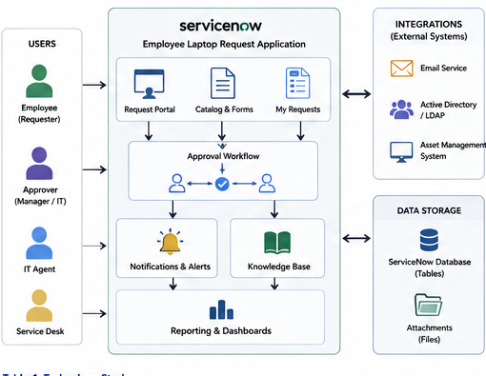
Table-1: Technology Stack:
S.No | Component | Description | Technology
1. | User Interface | How user interacts with application  (e.g., Request Portal, Catalog, Agent Workspace, Mobile UI, Notifications). | ServiceNow UI (Now Experience),  Service Portal, Responsive UI, Mobile App (Now Mobile)
2. | Application Logic - 1 | Business logic for raising laptop request, validations, and workflow initiation. | ServiceNow Flow Designer,  Business Rules, Script Includes (JavaScript)
3. | Application Logic - 2 | Approval workflow logic (manager, IT approvals) and task orchestration. | ServiceNow Workflow, Flow Designer,  Approval Policies
4. | Application Logic - 3 | Notification logic for updates and reminders. | ServiceNow Notifications,  Event Management
5. | Database | Application data storage (requests, tasks,  approvals, assets, users, etc.). | ServiceNow Database (Tables)
6. | Cloud Database | Platform database service in cloud. | ServiceNow Cloud (Oracle DB underlying)

S.No | Component | Description | Technology
7. | File Storage | Storage for attachments like justifications, invoices, documents. | ServiceNow Attachment Storage  (OCI Object Storage)
8. | External API - 1 | Used to send email notifications and reminders. | SendGrid / Microsoft Graph API  / SMTP API
9. | External API - 2 | Used for user data sync / validation with corporate directory. | Microsoft Graph API / Active  Directory (LDAP) API
10. | Machine Learning Model | Used for request categorization / suggestions (if applicable). | ServiceNow Predictive Intelligence  (Optional)
11. | Infrastructure  (Server / Cloud) | Application hosted on ServiceNow cloud platform. | ServiceNow Cloud (Multi-tenant)  on AWS

Table-2: Application Characteristics:
S.No | Characteristics | Description | Technology
1. | Open-Source Frameworks | List the open-source frameworks used. | N/A – ServiceNow is a proprietary platform. Uses open-source components internally (e.g., Angular, Bootstrap).
2. | Security Implementations | List all the security / access controls implemented, use of firewalls etc. | Role-Based Access Control (RBAC), ACLs, Data Policies, Encrypted Communication (HTTPS), SSO (SAML), MFA, IP Restrictions
3. | Scalable Architecture | Justify the scalability of architecture (3 – tier, Micro-services) | ServiceNow Multi-tenant Cloud Architecture, Horizontal Scalability, Load Balanced Infrastructure
4. | Availability | Justify the availability of application (e.g. use of load balancers, distributed servers etc.) | ServiceNow High Availability, 99.9% Uptime SLA, Load Balanced Instances, Automated Failover
5. | Performance | Design consideration for the performance of the application (number of requests per sec, use of Cache, use of CDN's etc.). | ServiceNow Platform Performance Analytics, Caching Mechanism, CDN for static content, Optimization of Business Rules & Queries
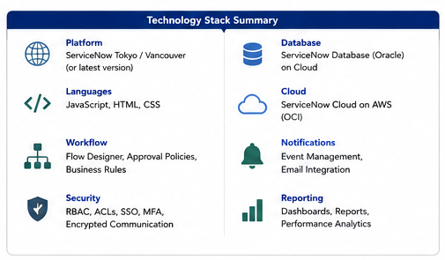
References:
🌐 https://www.servicenow.com/
🌐 https://docs.servicenow.com/
🌐 https://developer.servicenow.com/
🌐 https://www.servicenow.com/solutions/employee-experience.html
🌐 https://www.servicenow.com/products/it-service-management.html
🌐 https://www.servicenow.com/solutions/asset-management.html
🌐 https://www.servicenow.com/solutions/workflow-automation.html
🌐 https://www.servicenow.com/solutions/security-operations.html
Project Technology Scope Note:
This project will be built entirely on the ServiceNow Platform, leveraging
its ITSM, Workflow Automation, Catalog Management, and Integration
capabilities to deliver a seamless and secure Employee Laptop Request
experience. All data will be stored in ServiceNow cloud infrastructure
with role-based access, automated workflows, and real-time notifications.
Key Modules / Capabilities Covered:
